Viewing and scheduling reports

You can access reports through the dedicated Reports area via the top navigation, revealing the Reports dashboard. Within the Reports dashboard, click on a report's thumbnail or title to open and view it.

Sorting report results

The report data will appear in columns in the order set by the creator of the report, however columns can be sorted and hidden as required when viewing.

Clicking a highlighted column heading will re-sort the available data based on that column. An arrow will appear next to the column heading to indicate whether the data is sorted in ascending (A-Z for alphabetical data and 1-9 for numerical data) or descending order (Z-A for alphabetical data and 9-1 for numerical data).
A report viewer can choose to hide and unhide columns from their own display. Select the Show/Hide Columns button and use the checkboxes to hide or show the corresponding data columns then click the OK button.

Pagination
Where the maximum number of records to display per page has been reached, a report will become paginated. At the bottom of the page, use page numbers or the (Next) and (Previous) links to navigate through the data.

Searching report results
Search options will appear at the top of the report view page. Use the fields and filters to help search the report for specific data, such as a particular learner or date range. Click Show more... to show all available search fields.
Search options often have a dropdown menu where different options for data filtering can be selected.
After entering any search criteria, click the Search button. Results of the report will appear at the bottom of the page.
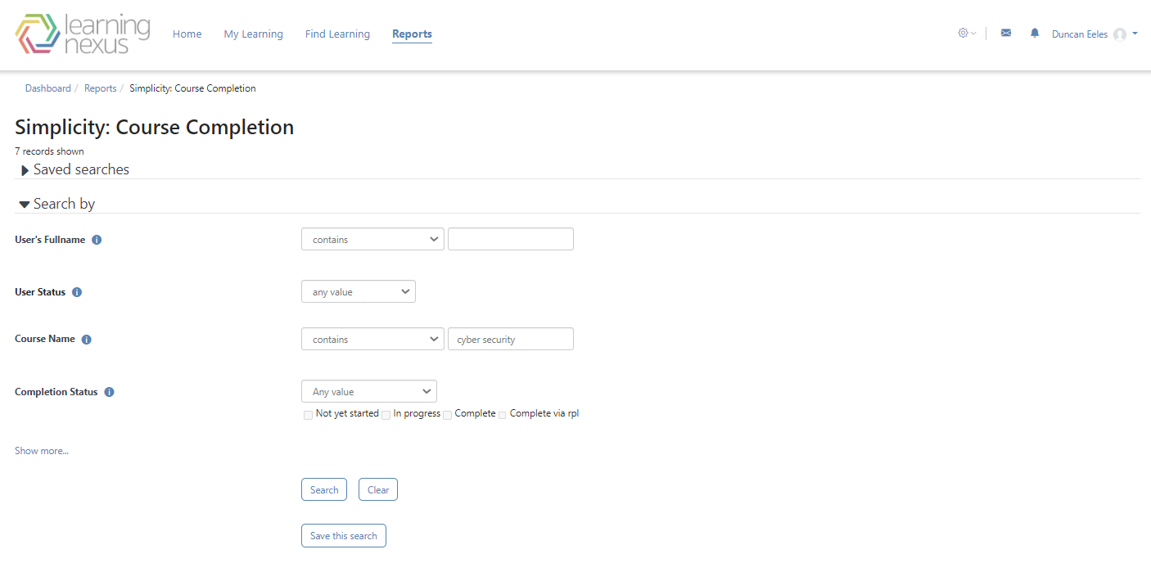

Saved searches

When viewing a report and using the search feature you can save searches to quickly return to them at a later date. A saved search allows report viewers to replicate a search and/or filters as required, or to share a search and/or filters with other report viewers.

Saved searches can also be used when setting up scheduled reports.
Once you (or other users) have created at least one shared saved search then the Saved searches section will be available at the top of the report. From here users can select different searches using the View a saved search dropdown list. As the report creator you can also select which saved search will be used as the default by choosing the search from the dropdown and clicking Set as your default view.
Use the Manage your saved searches page to edit or delete a saved search. Here you can see a list of saved searches visible to you (you will not be able to see other users' Private saved searches).
In the Options column you can either edit (edit cog) or delete (x) the saved search.

Save a report search
When viewing a report and using the search feature you can save searches to quickly return to them at a later date. Saved searches can also be used when setting up scheduled reports.
- Go to Reports from the top menu bar.
- Select the report you want to save a search for.
- Enter the search terms and filters you want to use.
- Click Save this search.
- Configure the settings.
- Click Save changes.
Once you (or other admin users) have created at least one shared saved search then the Saved searches section will be available at the top of the report. From here users can select different searches using the View a saved search dropdown list.

Schedule a report
You can schedule reports to run automatically by following these steps:
- Go to the Reports page from the top navigation bar.
- Scroll down to the Scheduled Reports section.
- Select the report from the dropdown menu.
- Click the Add scheduled report button.
- Configure the settings.
- Click Save changes.

