**Managing users**

Administrators will need to manage the site users, be that adding new user accounts, updating existing user accounts, or suspending the user accounts of leavers. To add new user accounts, administrators can create single users or bulk upload multiple users using a .csv file.

**Creating single users**

Go to *Quick-access menu > Users*.

Select the **Create user** button.

Complete the new user details. The mandatory fields are:

**Username**: <email address in lowercase>

**First name**:

**Last name**:

**Email Address:** *If a user doesn’t have an email address we suggest using what would be this user’s email address for your company, eg firstname.lastname@companydomain.com*

**Password / Generate password and notify user**: Either enter a password in the field and inform the user or select the Generate password option to have the system auto-generate a random password which will be emailed to the user at the point account creation.

Additional fields are also available, but are not mandatory – the most commonly used are:

* Department
* Job title
* Field
* Start date
* Manager

Scroll down and select the **Create user** button.

**Uploading multiple users**

Go to *Quick-access menu > Users*

Select the **Upload user** button.

You can click **Download**next to **CSV file template**to download a template file to upload with your user data – or use the template provided by Learning Nexus at INSERT LINK TO HELP SITE PAGE.

Select a file to upload and configure the settings (as described below).

If needed you can adjust the upload settings (**Encoding**, **Create password if needed and send via email** and **Force password** change).

You can also set a range of **User defaults**which can be used if information is not provided in the file you upload.

Click **Upload users**.

**Reset passwords and suspend users (leavers)**

Go to *Quick-access menu > Users*

Navigate to the relevant user and select the manage login (padlock) icon:

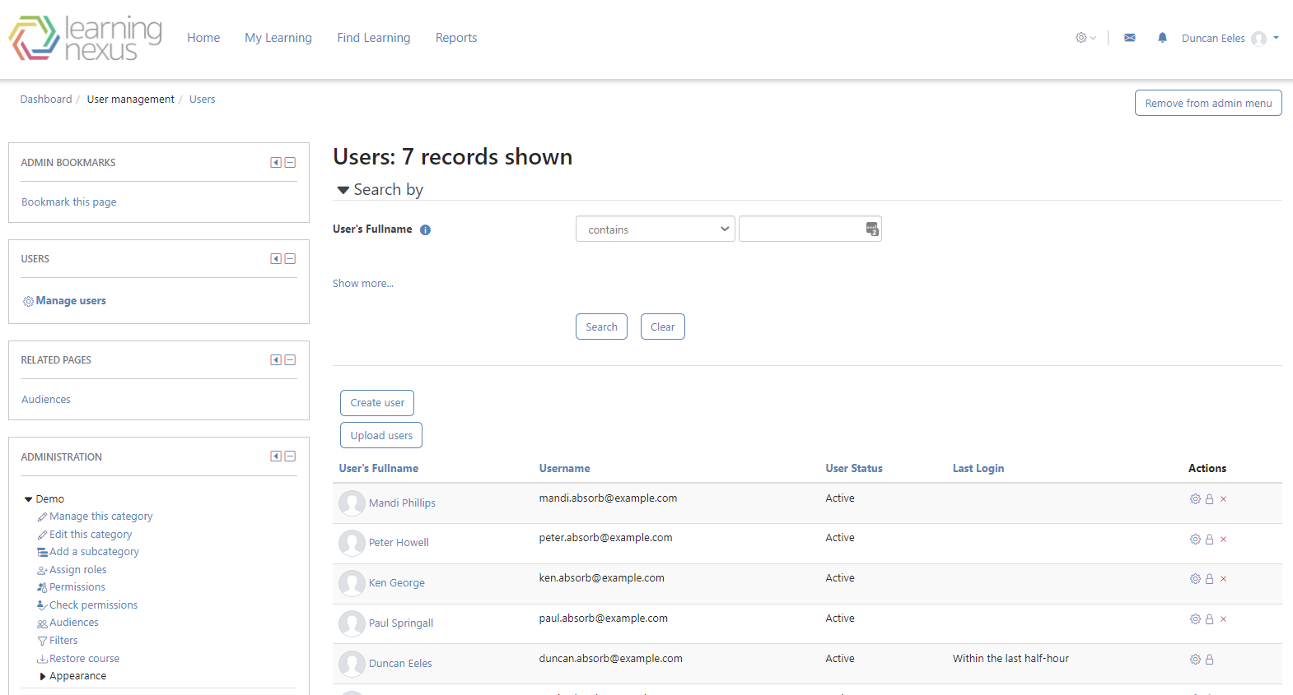

Choose either:

* Suspend user account
* Generate password and notify user
* Change password

**Update** the account