Assigning users to programs and certifications

Once Learning Nexus have created a program or certification for you, administrators can start assigning the learners who will need to complete the program/certification.

Once learners are assigned to a program/certification, they will be provided access to enrol in each selected course.

When adding learners to a program, go to Quick-access menu > Programs or Certifications and select the Enrolled users icon of the relevant title.

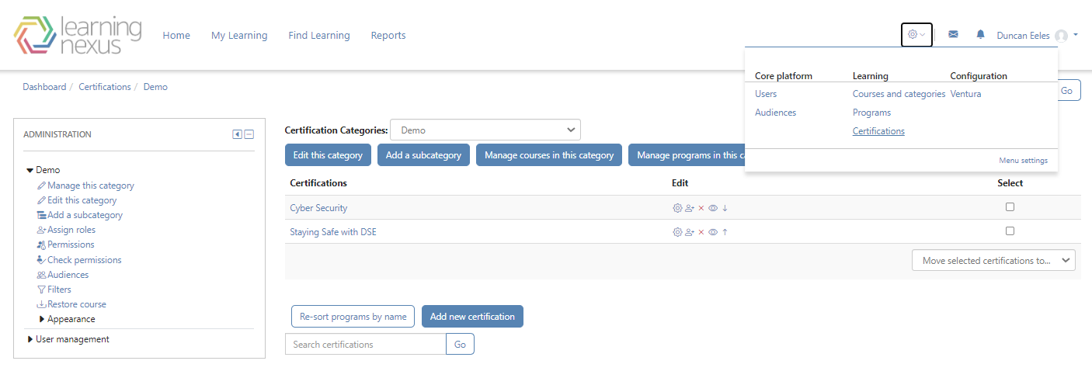
Select Individuals from the Add a new dropdown menu and click Add.
Select the Add individuals to program button.
Browse through the user list or Search for a specific individual.
Select the name of each individual to be added.
The selected individuals(s) appear under the Items to add area.
Select Ok to complete the selection of individuals or Cancel to exit.
Enter an Assignment due date.
Select Save changes.

