Learning Nexus VLE Implementation Check List

General:
- Proposed Launch Date

------------------------------------
- URL to be agreed – something similar to http://companyname.learningnexus.co.uk

---------------------------------------------------------------------------------------------------------------
- Password policy settings required for site. (e.g. minimum of 8 characters with at least 1 Capital, 1 Lowercase, 1 Special character – or no specific requirements)

---------------------------------------------------------------------------------------------------------------

---------------------------------------------------------------------------------------------------------------

---------------------------------------------------------------------------------------------------------------
- Email address for users to contact for admin support (e.g. site manager’s email address or helpdesk email address)

----------------------------------------------------------------------------------------------------------------
- Name and Email address of Site Manager/s

----------------------------------------------------------------------------------------------------------------

-----------------------------------------------------------------------------------------------------------------

-----------------------------------------------------------------------------------------------------------------
- Identify any custom user profile fields which will be included in reports and user upload template. (e.g. Directorate, Team, Business Area, Department, Payroll number etc.)

-------------------------------------------------------------------------------------------------------------------

-------------------------------------------------------------------------------------------------------------------

-------------------------------------------------------------------------------------------------------------------

-------------------------------------------------------------------------------------------------------------------
- What will the username be? (e.g. Payroll number, email address, ID number, Forename.Surname etc)

-------------------------------------------------------------------------------------------------------------------

- Will you require Cohorts to be set up across your site? If so, identify the Cohorts to be created. (Cohorts are useful if you wish to report by cohort or even enrol onto courses according to cohort).

-------------------------------------------------------------------------------------------------------------------

----------------------------------------------------------------------------------------------------------------------

----------------------------------------------------------------------------------------------------------------------

----------------------------------------------------------------------------------------------------------------------

----------------------------------------------------------------------------------------------------------------------

Branding and Home Page Set Up (see Image below for Standard Home Page)
- Logo (png format) and colours (RGB/HEX codes) for home page.

- Define welcome text to be included on home page. (refer to Standard Home Page Image)

-------------------------------------------------------------------------------------------------------------------

-------------------------------------------------------------------------------------------------------------------

-------------------------------------------------------------------------------------------------------------------

-------------------------------------------------------------------------------------------------------------------

- Any title amendments to category blocks (refer to Standard Home Page Image)

-------------------------------------------------------------------------------------------------------------------

-------------------------------------------------------------------------------------------------------------------

-------------------------------------------------------------------------------------------------------------------

-------------------------------------------------------------------------------------------------------------------

- Define which courses should be accessed through the three short cuts within the carousel (Currently set to Data Protection, Freedom of Information and Introduction to Health & Safety)

-------------------------------------------------------------------------------------------------------------------

-------------------------------------------------------------------------------------------------------------------

-------------------------------------------------------------------------------------------------------------------

- Is the Standard Certificate attached to each course (see image below) required.

------------------------------

User Upload:
- User upload template to be completed and returned to support@learningnexus.co.uk (template will be sent once any custom user profile fields have been defined).

---------------------------------------------------------------------------------------------------------------------

- What default password is to be used for initial bulk user upload? (Each user will then be forced to change the default password on first login).

---------------------------------------------------------------------------

- Are users to be enrolled onto any specific course/s as part of the initial user upload?

------------------------------------------------------------------------------------------------------------------

------------------------------------------------------------------------------------------------------------------

- Are users to be added to any cohorts as part of the initial user upload?

-------------------------------------------------------------------------------------------------------------------

Enrolment:
- Do you require manual enrolment by Site Manager or self-enrolment by learner? (This can be course specific)

-----------------------------------------------------------------------------------
- Should any enrolment period be defined for any or all courses?

-----------------------------------------------------------------------------------
Roles:
- Identify who will be the Site Manager/s

-----------------------------------------------------------------------------------------------------------------------------

- Identify any other roles you may require and what permissions you wish them to have (E.g. HelpDesk – User Management permissions only).

-----------------------------------------------------------------------------------

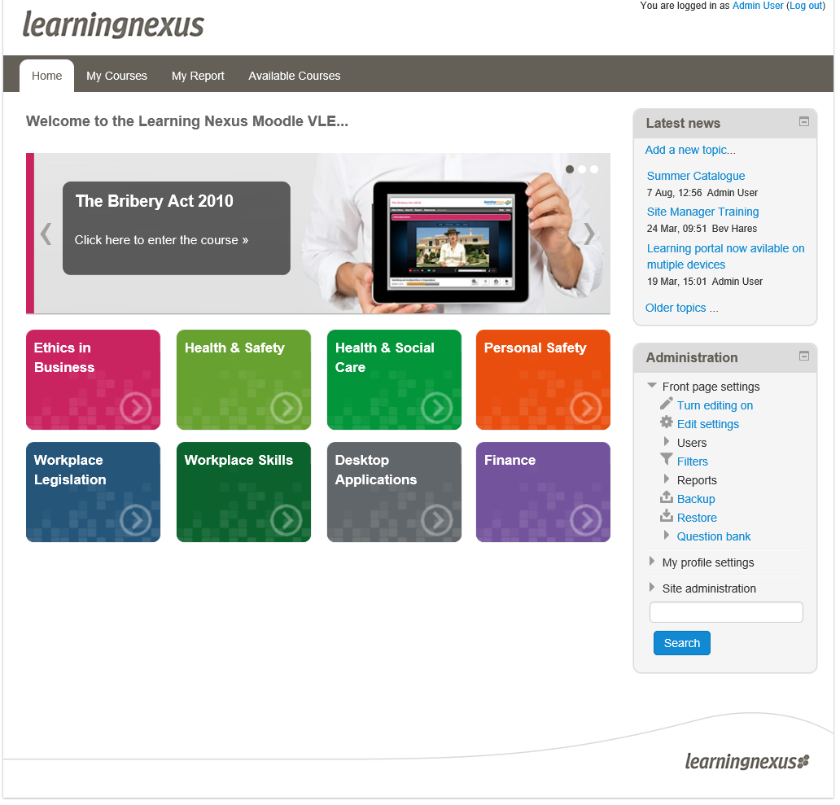
Fig 1: Learning Nexus VLE Home Page

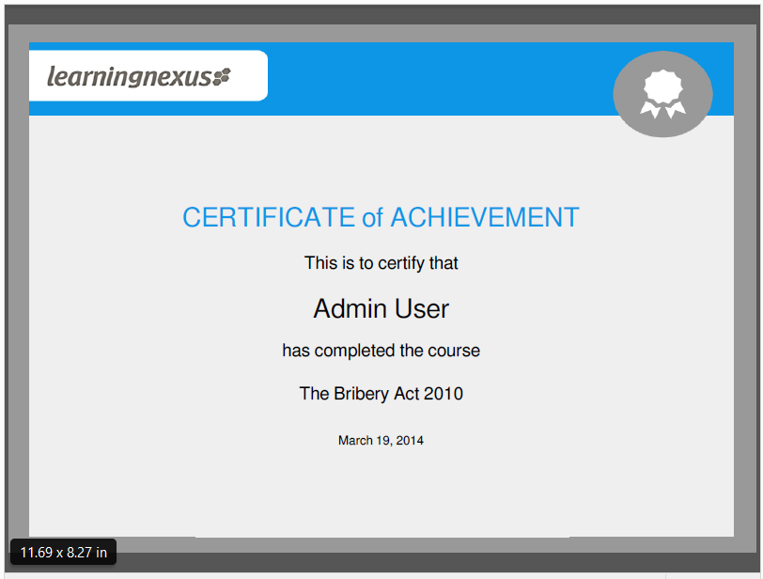
Fig 2: Learning Nexus Course Certificate

