Accessing Reports

There are a number of different types of reports that are available on the Learning Nexus VLE. There are the standard system reports and also the additional reports plugin that has been developed for us.
It’s also important to note that a ‘course’ consists of a number of ‘activities’ and depending on the course settings, a course may not be shown as complete until certain activities have been completed. The standard set up for the Learning Nexus VLE is that either the audio or non-audio SCORM activity must be completed (and passed) for the course to shown as completed.
NB: Some of our customers also have an additional activity of a ‘Course Feedback Evaluation’ which must also be submitted in order for the course to be shown as completed.

Standard System Reports
With a course selected you will see the Administration Block which will display the ‘Course Administration’ menu and an option for Reports which lists a selection of different types of reports that are available within a course:
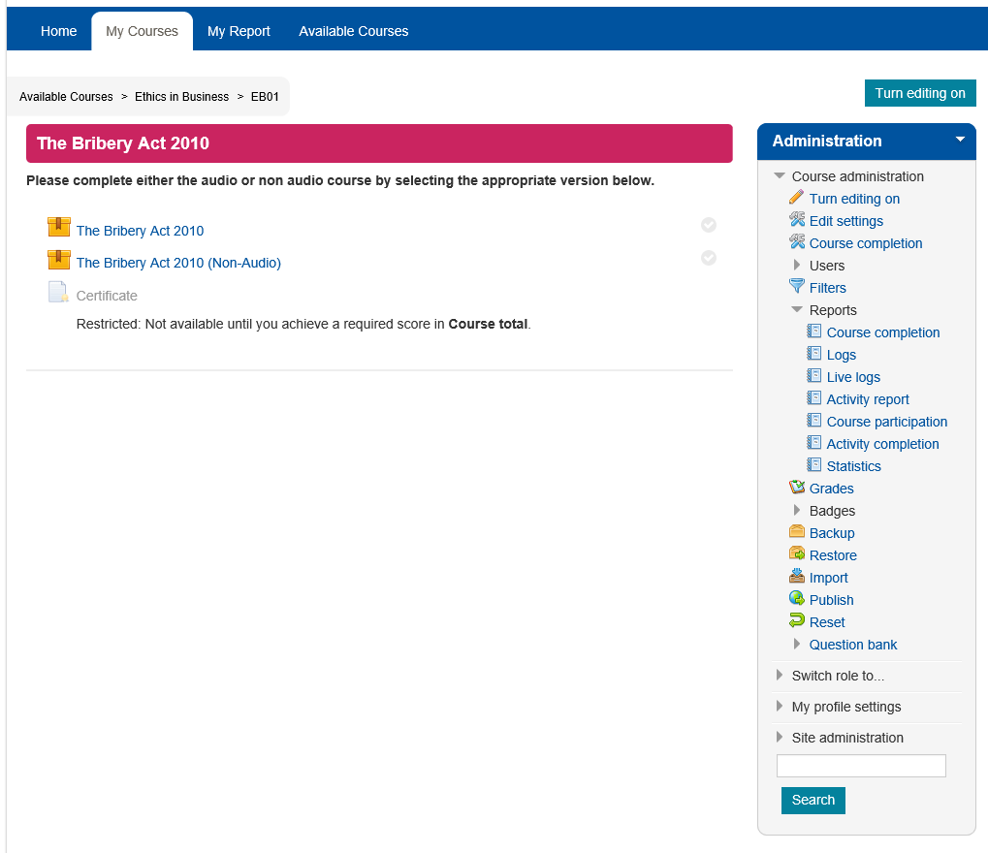

These report options allow you to view a selection of ‘Course completions’, ‘Activity completions’ and ‘Logs’.
Course Completions (Course Page>Course Administration>Reports>Course Completion)
Course completions will show a list of the users enrolled on the course and will display a tick against the activity or activities completed and a tick in the course complete column for those that have subsequently completed the course. There is also an option to download these results to excel.
If there are a large number of users in the list there is also an option to filter by first name and/or surname.
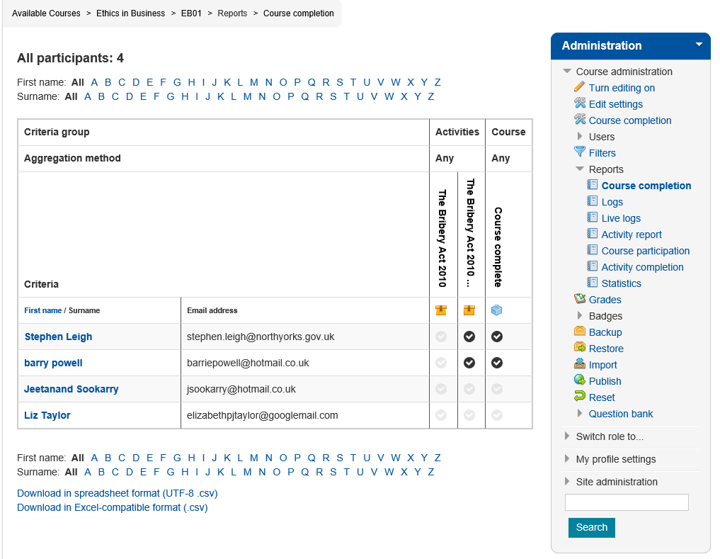
Course Completion Report
Activity Completion (Course Page>Course Administration>Reports>Activity Completion)
Similarly to the course completion report, this activity completion report will show a breakdown of the activities within this course and will display a tick against any activities that have been completed for the users that have been enrolled on this course. This information can be downloaded to excel.
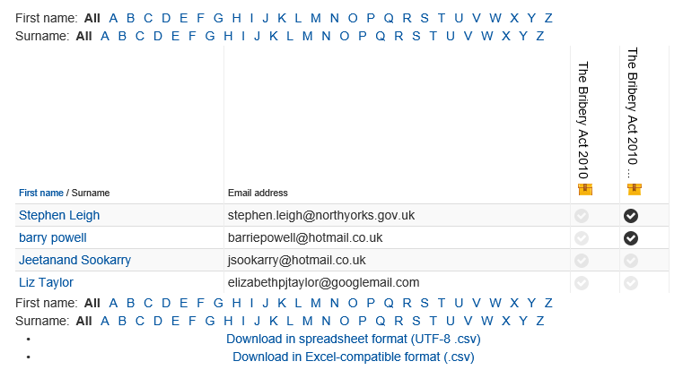
If there are a large number of users in the list there is also an option to filter by first name or surname.

Activity Completion Report

Activity Report (Course Page>Course Administration>Reports>Activity Report)
The activity report provides further information regarding the activities that have been accessed within the course. In the example below you will see there are 3 activities for the Bribery Act 2010 course. This report will display the number of views for each activity and the date and time the activity was last accessed.
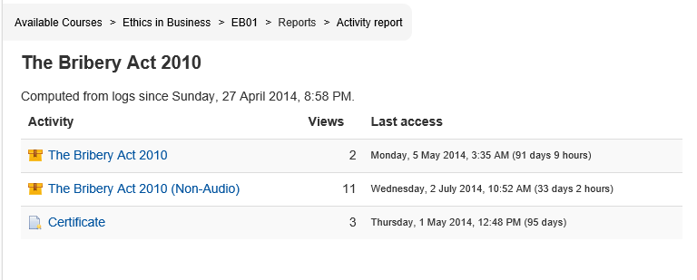
Activity Report
By selecting one of these activities, you can then select another option for ‘Reports’ from within the activity itself.
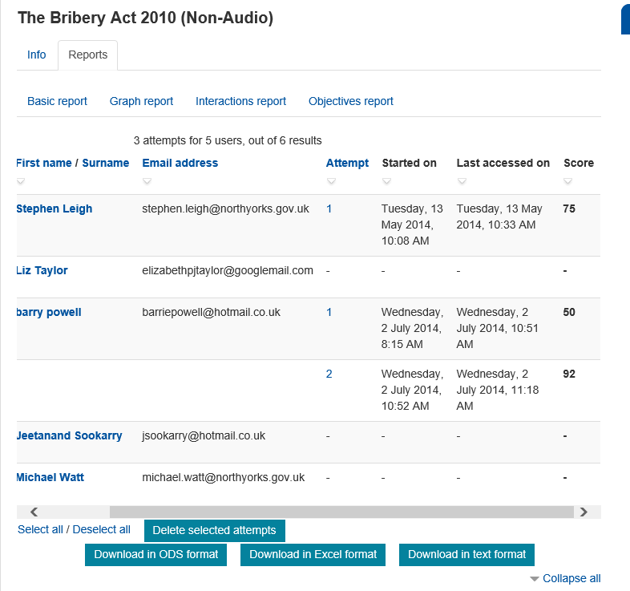

Activity Report – Basic Report
This report option has a number of display options:
Basic report, Graph report, Interactions report and Objectives report.
Basic report: This will show you the name, email address, number of attempts, date started, last accessed and any score achieved. This report can be downloaded to excel.
Graph report: This report displays the information in graph format.
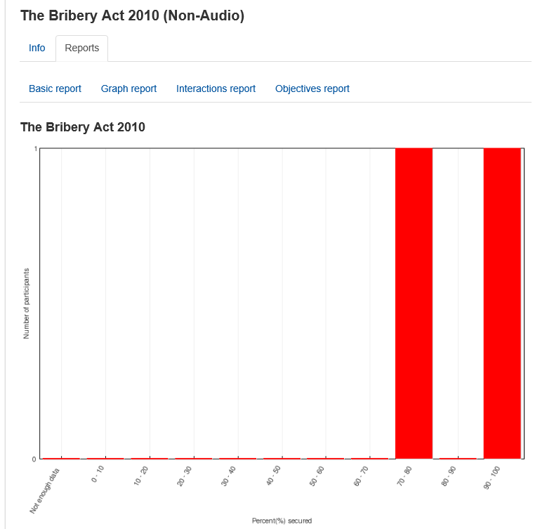

Activity Report - Graph Report
Interactions and Objectives Reports: These provides very similar data to the basic report but include pass/fail indication in the form of a green tick or red cross along with the score achieved and will also indicate if an activity has ‘not been attempted’. This data can be downloaded to excel.
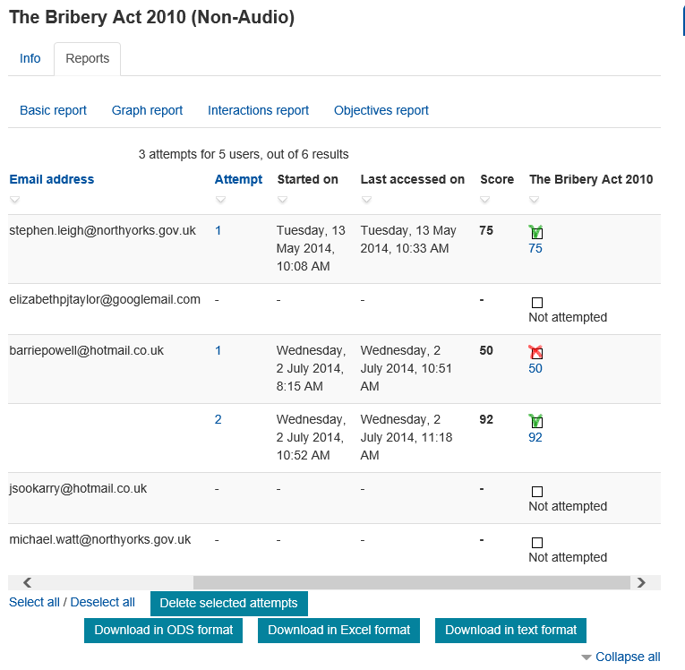

Activity Report – Interactions report

Additional Reports – MC Reports
These reports have been developed specifically for Learning Nexus and are in addition to the above standard reports.
As a Site manager you can access these reports from the Administration block Site administration>MC Reports
There are then three options:
- Course Access Report
- Course Completion Report
- Course Enrolment Report
Course Access Report
This report allows you to run a report for all courses by not selecting anything in the course list. Or, you can choose one or multiple courses by holding the Ctrl key down and selecting the course/s you want to include.
Select the dates required and place a tick in the ‘Enable’ box – If the date fields are not enabled, it will search all dates.
Click search.
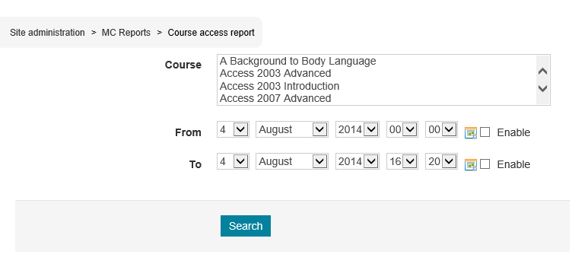
Course Access Report Filters
The report displayed will show you a list of the courses selected and the number of accesses for each course. You will also see an overall summary at the top.
This report can be downloaded as a CSV file
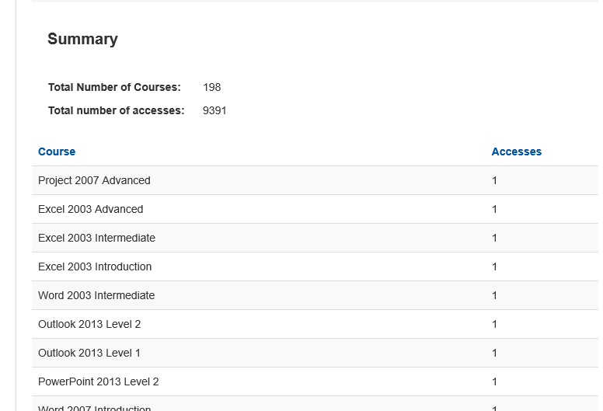
Course Access Report

Course Completion Report
This report allows you to select a cohort/s, course/s, status of ‘all’, ‘not started’, ‘in progress’, or ‘completed’ and a Completed date range.
NB: If a date range is enabled then you will only see those with a status of ‘Completed’
If you don’t select anything it will include all cohorts, all courses and all status across all dates.
The report can be downloaded to CSV file.
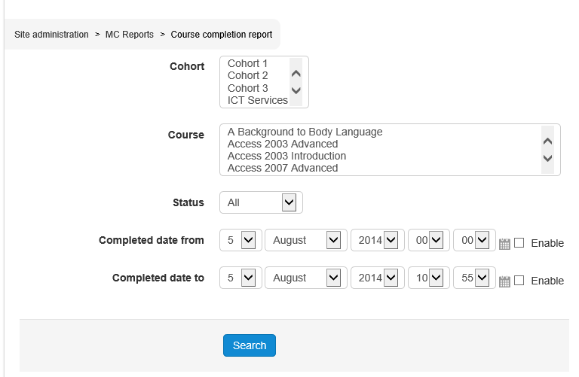
When the report is displayed it will include data in the following columns:
- First Name
- Surname
- Username
- Email address
- Course
- Cohort
- Custom User Profile fields – these can be configured according to requirements.
- Status
- Date enrolled
- Date started
- Date completed
- Total time
- Grade
There will also be a summary at the top of the page
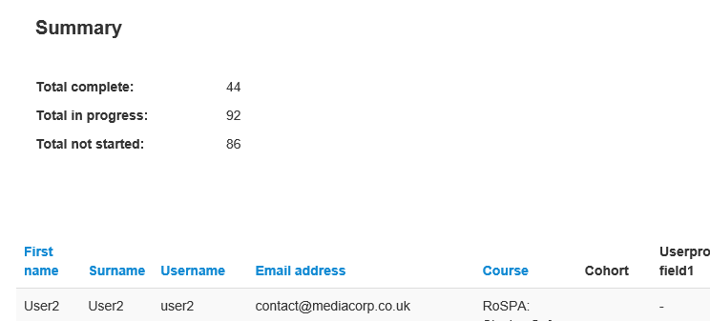
Course Completion Report

Course Enrolment Report
This allows you to select a course/s and a date range and will display the number of enrolments for the courses selected. If a date range is selected then the ‘enable’ boxes must be ticked.
This report can be downloaded to CSV.
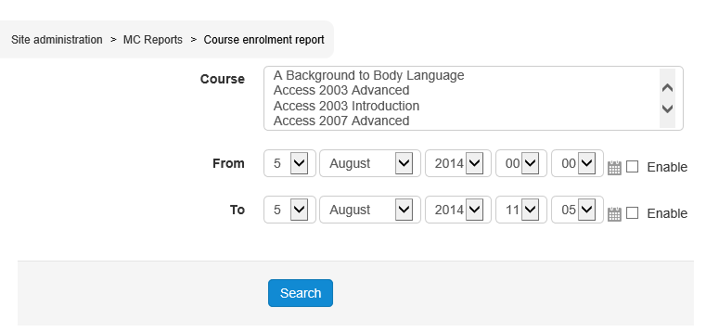
The report will display a list of the courses and the number of enrolments. There will be a summary of the overall number of enrolments at the top of the screen.
The report can be downloaded to excel
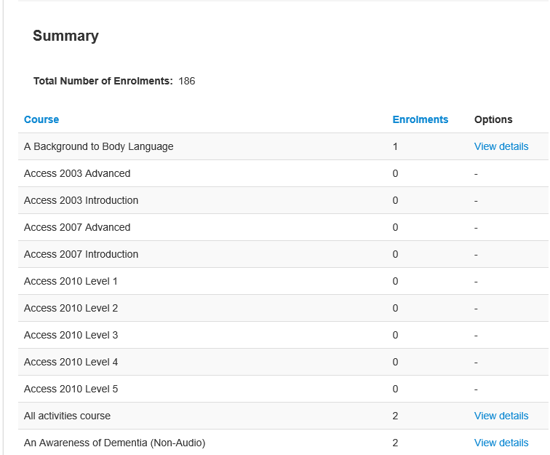
Course Enrolment Report

There will be a view details option against any course that has a number of enrolments. By clicking on this you will see further details about the users that have been enrolled on the selected course.
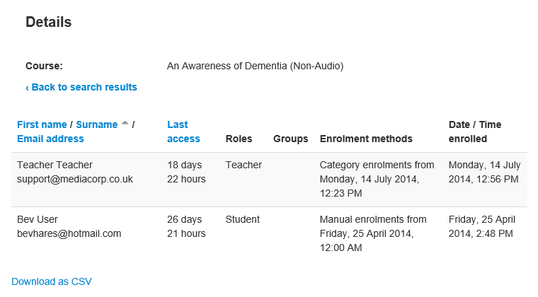
View Details for Course Enrolments
This information can also be downloaded to excel.

Additional Reports – MC Schedule Reports
In order to assist with the administrative tasks, Learning Nexus have also included some further developed reports that can be scheduled to run on a particular date with a recurring option for daily, weekly or monthly.
These reports are emailed to a specific recipient on the scheduled date and time and are not displayed within the VLE.
These reports can be set by selecting Site Administration>MC Reports
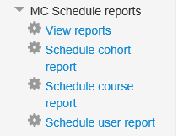
There are a number of options here. You can view any existing scheduled reports or create new scheduled reports.
View Reports
To view any existing scheduled report select the ‘view reports’ option.
Here you will see a list of existing scheduled reports. You can either delete the report if it is no longer required or edit it. Editing it will allow you to change the recipient and the date and time it is scheduled to run.
Schedule Cohort Report
To schedule a cohort report, select Site administration>MC Schedule reports>Schedule cohort report
There are two mandatory fields that must be completed for:
- Cohort (select one cohort from the drop down list)
- Email report to (select one recipient from the drop down list)
You will then be asked to select a date and time for the report to run
If you wish the report to recur then place a tick in the box and then select from the drop down box how often you want this to recur i.e. Daily, Weekly or Monthly
If you have chosen to schedule a recurring report, you can also set an end date.
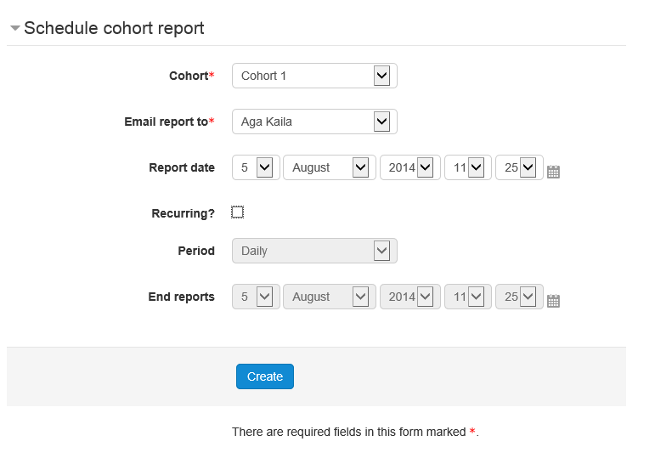
Schedule cohort report
Having selected ‘Create’ the report will then run at the scheduled time and date and will be sent via email to the specified recipient.
The email will contain data under the following column headings:
- Name
- Username
- Email address
- Custom User Profile fields (e.g. payroll number, post title, business area etc.)
- Course title for each course users are enrolled on (will display a dash if the course has not been completed or if the pass mark was not achieved and will display a date and time if the course has been completed)

Schedule Course Report
To schedule a course report, select Site administration>MC Schedule reports>Schedule course report
There are two mandatory fields that must be completed for:
- Course (Select one course from the drop down list)
- Email report to (select one recipient from the drop down list)
You will then be asked to select a date and time for the report to run
If you wish the report to recur then place a tick in the box and then select from the drop down box how often you want this to recur i.e. Daily, Weekly or Monthly
If you have chosen to schedule a recurring report, you can also set an end date.
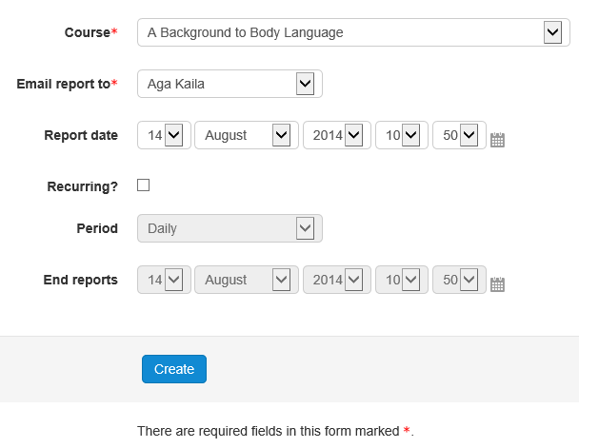
Having selected ‘Create’ the report will then run at the scheduled time and date and will be sent via email to the specified recipient.
The email will contain data under the following column headings:
- Name
- Username
- Email address
- Custom User Profile fields (e.g. payroll number, post title, business area etc.)
- Activity title and status (e.g. Not Completed)
- Activity title and completion date (if completed)
- Course completion (will be blank if not completed)

Schedule User Report
To schedule a User report, select Site administration>MC Schedule reports>Schedule User report
There are two mandatory fields that must be completed for:
- User (Select one user from the drop down list)
- Email report to (select one recipient from the drop down list)
You will then be asked to select a date and time for the report to run
If you wish the report to recur then place a tick in the box and then select from the drop down box how often you want this to recur i.e. Daily, Weekly or Monthly
If you have chosen to schedule a recurring report, you can also set an end date.
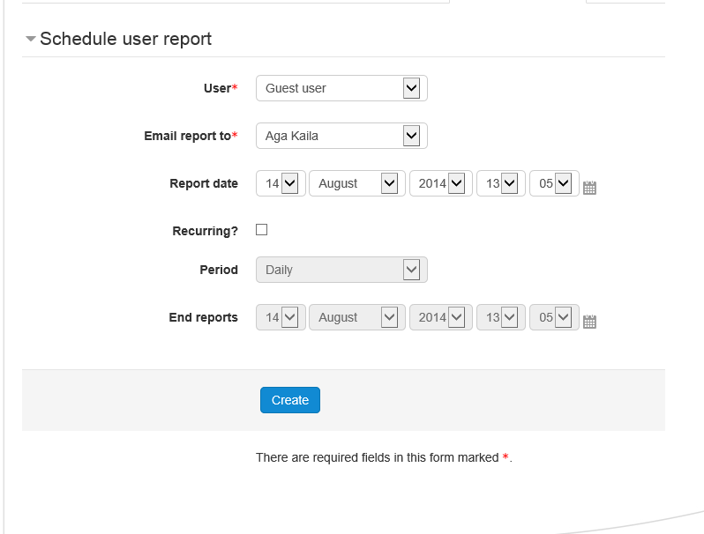
Schedule User Report
Having selected ‘Create’ the report will then run at the scheduled time and date and will be sent via email to the specified recipient.
The email will contain data under the following column headings:
- Name
- Username
- Email address
- Custom User Profile fields (e.g. payroll number, post title, business area etc.)
- Course title (will display a dash if the course has not been completed or if the pass mark was not achieved and will display a date and time if the course has been completed)

MC Alerts

The MC Alerts allows a Site Manager to run an alert for a specified Cohort or all users enrolled on a specified course at a specified date and time. The alert will send an email and appear in the Users ‘My Courses’ tab on the LMS and will either be:
- A general message to those users
- A message to only those that have completed the course
- A message to those who have not completed the course.
To send an alert, select Site administration>MC Alerts>Create a new alert
There are two mandatory fields that must be completed for:
- Alert Title
- Description
These are both free text boxes for you to add the text you wish the user to receive.
You can select a specific cohort (or leave on All cohorts), you also need to select the course to which this alert applies.
NB: If you use the course completion or non-completion alert then completion must be enabled on that course.
Select a date and time for the report to run.

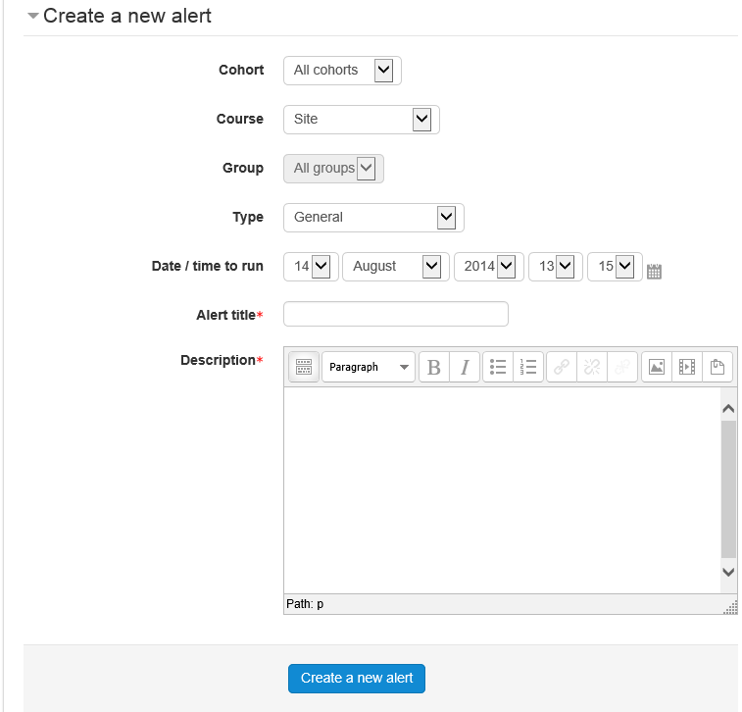

At the specified date and time an email will be sent to all users in the selected cohorts that have been enrolled on the selected course that match the alert type i.e.
- Everyone, if it is a general message.
- Only those who have completed the course, if it is a ‘Course Completion’ alert.
- Only those who have not completed the course, if it is a ‘Course Non-Completion’ alert.
View Live Alerts
As a Site Manager, you can view any live alerts i.e. any alert that is due to run. These live alerts can be edited by a Site Manager.
To view live alerts select Site administration>MC Alerts>View live alerts
View Expired Alerts
As a Site Manager You can view expired alerts. This will then allow you to ‘view details’ of an alert displaying a list of the users who were sent this alert.

