**How to improve your Adapt course’s accessibility**

**Introduction**

Adapt takes accessibility seriously, and the authoring tool offers a number of built-in features which allow you to ensure that the courses you create are accessible.

While the authoring tool allows you to finely tune a range of settings related to accessibility, many of these settings, such as ARIA labels and levels, are correctly configured ‘out of the box’.

This guide will cover:

* What a screen reader is, and how it works
* How to improve your course’s accessibility in just a few minutes
* Recommended screen readers you can use for free
* Alternative text examples
* Key takeaways

**What is a screen reader, and how does it work?**

A screen reader is a piece of software which allows visually impaired visitors to websites and web applications to access all or most of the displayed content.

As you’ll see below, not *all* content necessarily needs to be accessible; but what *is* important is that all *significant learning content* is accessible. This will include things like:

* Body text and instruction
* Images which relate directly to learning content
* Titles, headings, button labels and navigable contents
* Other significant media, such as audio and video

When a screen reader is active and focus is given to an **element** on the page, each preceding and subsequent element can be reached by using the **Up and Down arrow keys on your keyboard**. As the screen reader reaches each element, it will attempt to read out the content it finds there.

So what about images? A screen reader will have nothing to read out if it comes across an image which has been given no **alternative text**. Instead, the screen reader will skip right past the image, which could, from the perspective of a visually impaired learner, negatively alter the course flow or pace, create gaps in the learning, and generally ruin the learning experience.

**Alternative text**

Alternative text is one of the most important areas for consideration when it comes to making your course accessible. Alternative text is a concise, accurate description of an image, which will be read out by screen readers and displayed when an image fails to load.

When a screen reader reaches an image which has alternative text, it will read out this text in place of the image. This means that even though a learner may be unable to view the image, its meaning and significance can still be conveyed.

Below are a few examples of alternative text. Notice how it’s equally important to provide alternative text for **titles** and other **text-based images**, as well as **photos** and **illustrations**.



**Alternative text**   
A photo showing a person wearing personal protective equipment, surrounded by building materials.



**Alternative text**   
An illustration showing a group of workers, some dressed in business attire, some in personal protective equipment.

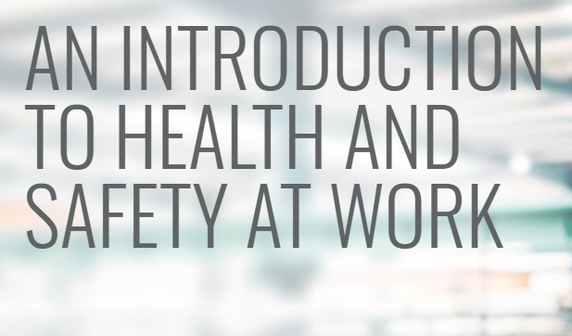

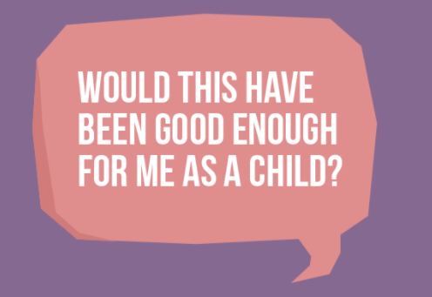**Alternative text**   
A title which reads: “An Introduction to Health and Safety at Work”.

**Alternative text**   
A speech bubble which reads: “Would this have been good enough for me as a child?”



**Alternative text**   
Statistics which read: “Almost 560 children were trafficked for sexual exploitation in 2017”, and “1,400 children were sexually exploited in Rotheram in 1997 to 2014”.

Notice how the final example uses “to” instead of a dash. Screen readers are unable to establish the meaning or context of alternative text. So in this case, if the word “to” was not given, the screen reader would simply ignore the dash (not knowing it’s part of a date range) and the learner would only hear “1997 2014”.

**TIP**  
With the ‘**Developer tools**’ extension added and enabled, check the box labelled ‘**Show alt text**’ in the extension’s drawer. This will display any alternative text you’ve added, and flag wherever alternative text is missing.

Screen readers will also likely fail to correctly pronounce certain names or other uncommon words. For this reason, you should *always test your courses*. You may find that learning content needs to be altered in order for it to be accessible.

**Recommended screen readers**

Accessibility is an increasingly crucial aspect of high-quality and inclusive design, so it’s unsurprising that there are many screen readers available to download. While some screen reader software comes with a price tag, there are some popular options you can use for free in order to test your own course’s accessibility. These are **Narrator**, **NVDA**, **Orca** and **VoiceOver**.

**Narrator**If you’re using Windows, you’ll already have instant access to screen reader software. Start and exit Narrator with **Windows logo key [Insert Windows logo here] + Ctrl + Enter**. You can then make your way through your course’s page with the **Up and Down arrow keys** and the **Tab key**.

You’ll need to ensure that Narrator’s **Scan** mode is enabled in order to hear sentences and paragraphs read out. Scan mode can be toggled on and off with **Caps Lock + Spacebar**.

*Learn more about Narrator by going to https://support.microsoft.com/en-us/help/22798/windows-10-complete-guide-to-narrator*

**NVDA**NVDA is one of the most well-known pieces of screen reader software, and is open source and free to download for Windows.

Once you’ve launched NVDA, you can access preferences, help and other tools with **Insert + N**. This is also where you’ll need to go in order to exit the screen reader.

Similar to Narrator, make your way through the page by using the **Up and Down arrow keys** and the **Tab key**.

*Learn more about NVDA by going to https://www.nvaccess.org/about-nvda*

**Orca**  
For users of the GNU/Linux operating system, Orca is a popular option. It is free open source software and can be installed for most GNU/Linux distributions.

*Learn more about Orca by going to https://help.gnome.org/users/orca/stable*

**VoiceOver**  
For Mac users, VoiceOver comes built-in with many features and a lot of potential for customisation.

*Learn more about VoiceOver by going to https://www.apple.com/accessibility/mac/vision*

**Key Takeaways**

* Quality screen reading software is freely available for Windows, Mac and GNU/Linux.
* Most screen readers use similar keybindings, but these can be customised in the software’s preferences or settings.
* Alternative text should be added to any element which contains learning or other significant content.
* The ‘Developer tools’ extension allows you to display any alternative text you’ve added, and indicate where alternative text is missing.
* Thoroughly test your course with a screen reader in case last-minute alterations are needed.